ASSIGNMENT 2: PYTHON & BASH

1. Grade Checker
Take a score as input and print the grade based on the following:
- 90+ : “A”
- 80–89 : “B”
- 70–79 : “C”
- 60–69 : “D”
- Below 60 : “F”
- Use a basic if / else statement to determine the grade.
Output:
score = int(input("Enter your score: "))
if score >= 90:
print("Grade: A")
elif score >= 80:
print("Grade: B")
elif score >= 70:
print("Grade: C")
elif score >= 60:
print("Grade: D")
else:
print("Grade: F")

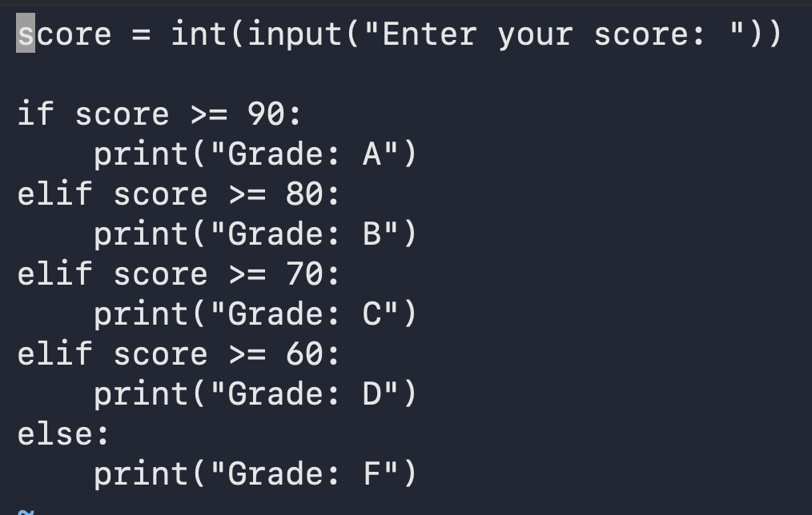
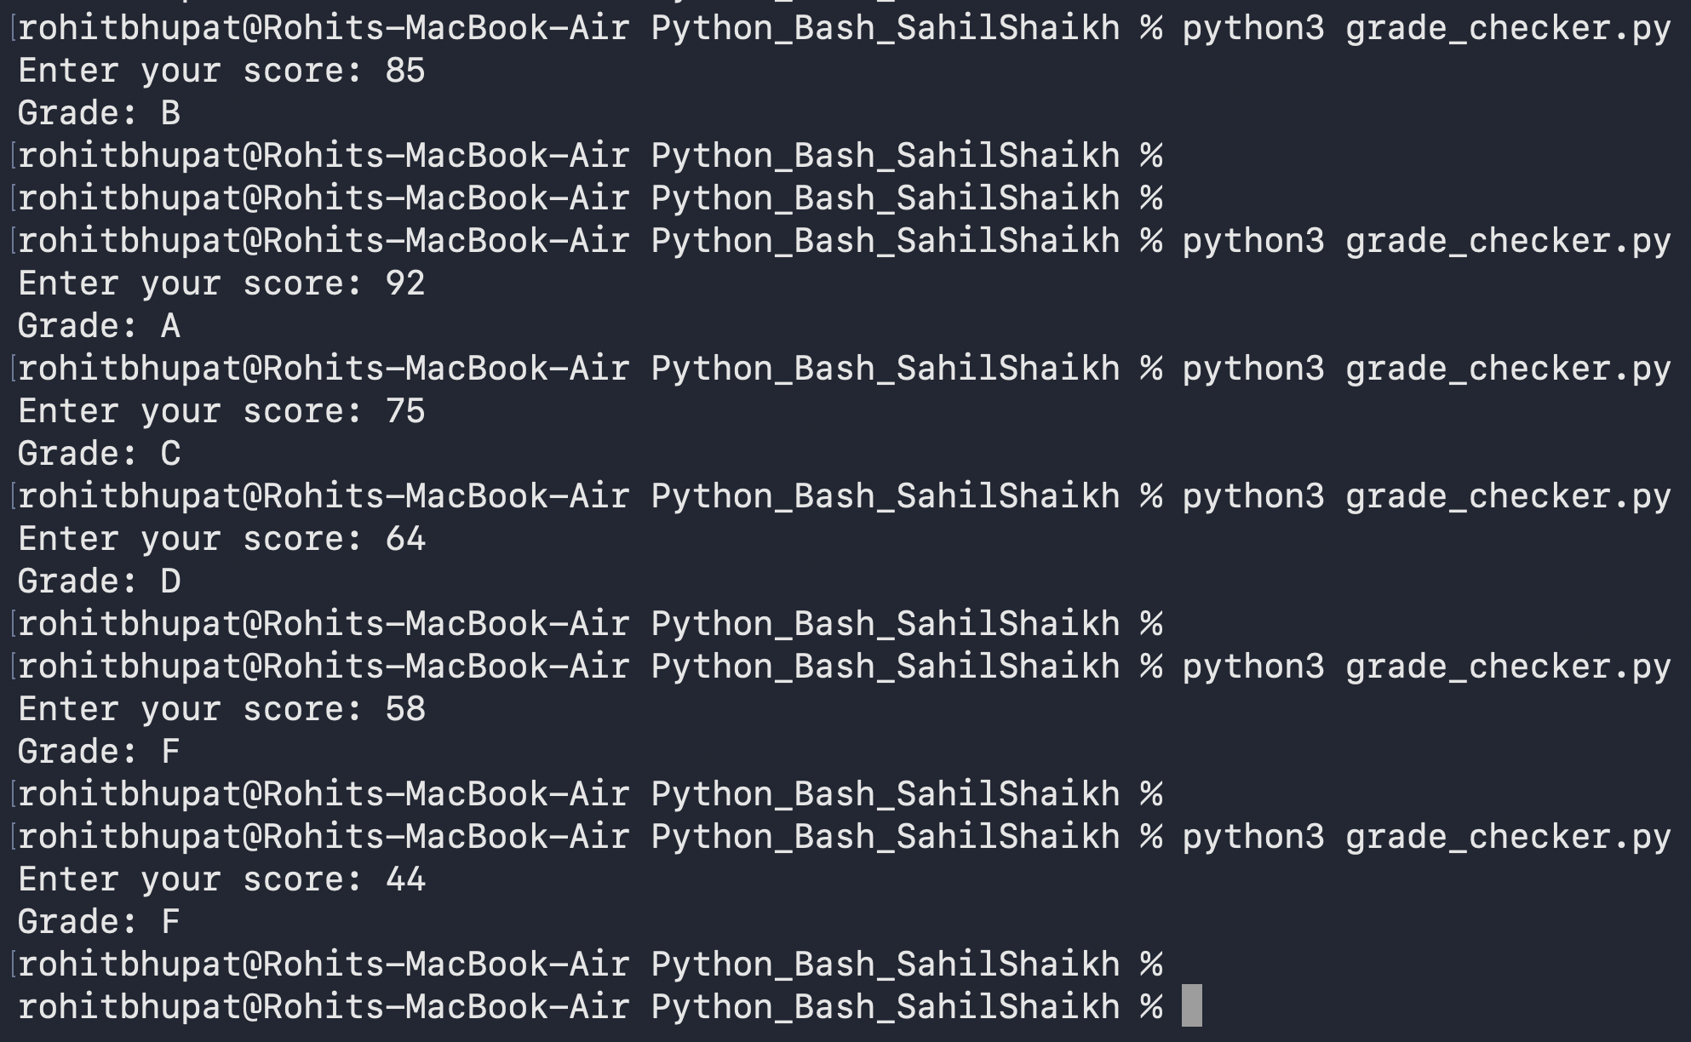
Explanation:
- input() is used to accept the student's score from the user.
- int() converts the entered score into an integer.
- The if statement checks whether the score is 90 or above and assigns Grade A.
- The elif statements check the remaining score ranges to assign Grades B, C, and D.
- The else statement assigns Grade F if the score is below 60.
- print() displays the final grade.
Result: The program successfully determines and displays the student's grade based on the entered score. For example, if the user enters 95, the program displays Grade A.

2. Student Grades
Create a dictionary where the keys are student names and the values are their grades. Allow the user to:
- Add a new student and grade.
- Update an existing student's grade.
- Print all student grades.
- Use a dictionary and basic operations with if / else.
Output:
students = {
"Sahil": 85,
"Sameer": 92,
"Faisal": 78,
}
name = input("Enter student name: ")
grade = int(input("Enter grade: "))
if name in students:
students[name] = grade
print("Student grade updated successfully.")
else:
students[name] = grade
print("New student added successfully.")
print("\nAll Student Grades:")
for student, marks in students.items():
print(f"{student}: {marks}")

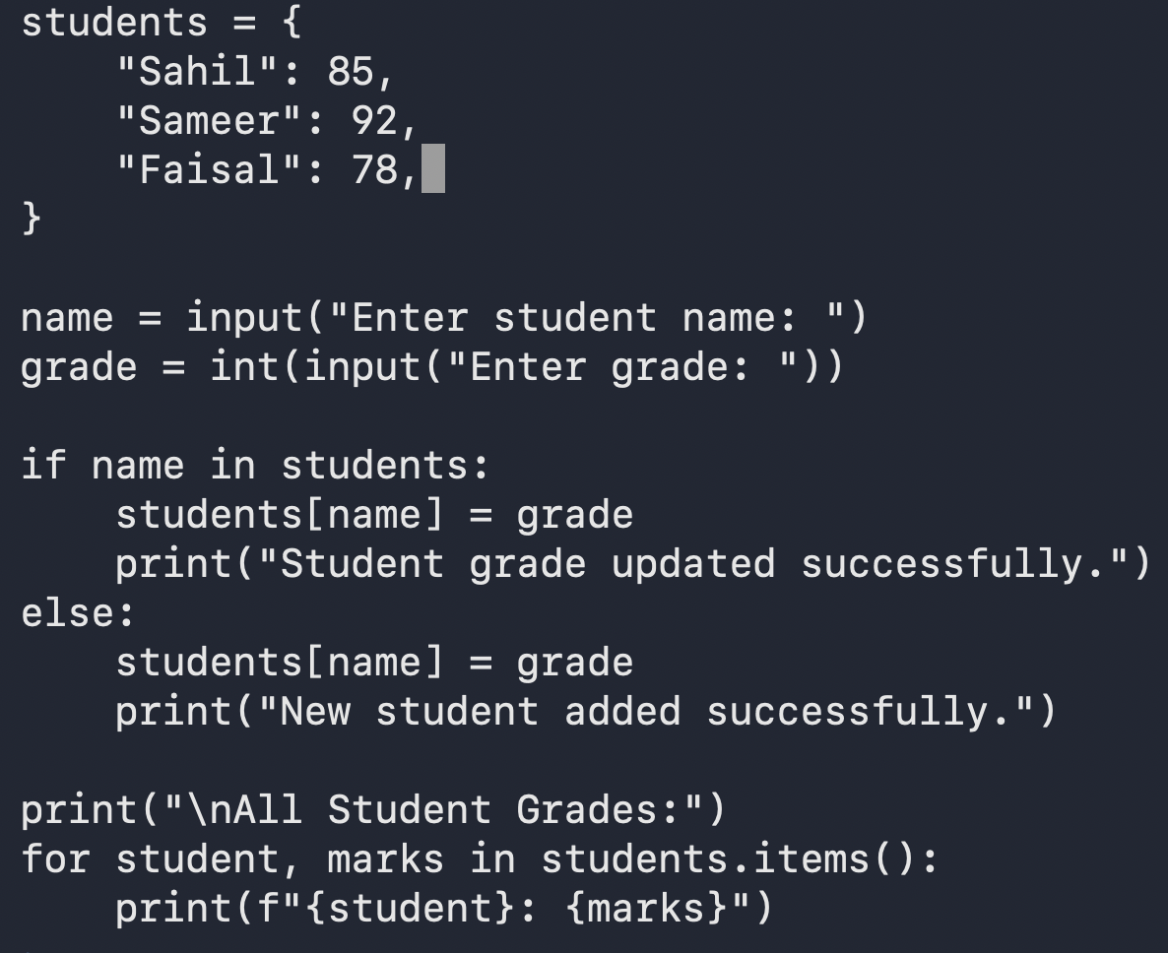
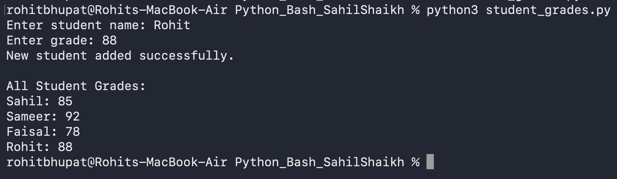
Explanation:
- A dictionary named students is created to store student names as keys and their grades as values.
- input() accepts a student's name and grade from the user.
- The if statement checks whether the student already exists in the dictionary.
- If the student exists, the program updates the student's grade.
- Otherwise, the program adds the new student and grade to the dictionary.
- The for loop with .items() displays all student names and their grades.
Result: The program successfully adds new students, updates existing students' grades, and displays all student records stored in the dictionary.
3. Write to a File
- Write a program to create a text file and write some content to it, using file functions like open() and write().
Output:

file = open("sample.txt", "w")
file.write("Hello, this is my first file.\n")
file.write("I am learning Python file handling.")
file.close()
print("Data written to file successfully.")

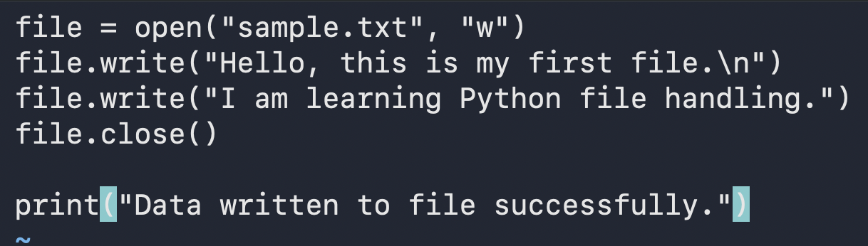
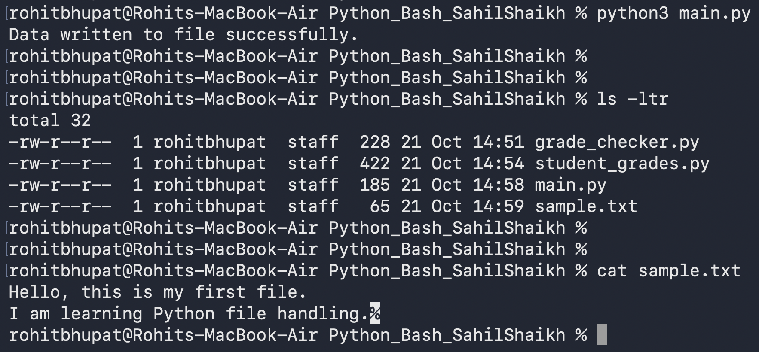
Explanation:
- open("sample.txt", "w") creates a file named sample.txt in write mode. If the file already exists, its previous contents are overwritten.
- The write() function writes text into the file.
- The \n character moves the second line of text to a new line.
- close() closes the file after writing is complete.
- print() displays a confirmation message in the terminal.
Result: The program successfully creates the text file and writes the specified content into it. The terminal displays the message "Data written to file successfully."
4. Read from a File
- Open the file in read mode and use file.read() to read and display its content.
Output:
file = open("sample.txt", "r")
content = file.read()
print("File Contents:")
print(content)
file.close()

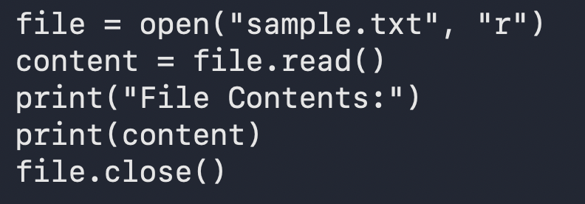
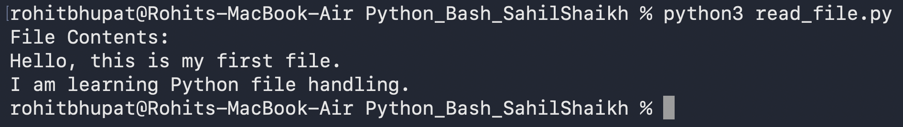
Explanation:
- open("sample.txt", "r") opens the existing file in read mode.
- read() reads the entire contents of the file.
- The variable content stores the text read from the file.
- print() displays the file contents in the terminal.
- close() closes the file after reading is complete.
Result: The program successfully reads and displays the contents of sample.txt in the terminal. It demonstrates how Python can retrieve and display data stored in a text file.

